**Problem**

Inequalities in almost every aspect of the daily lives of many minorities are a major factor in why minority communities lack the resources and opportunities their more affluent counterparts face. Minority groups need help to combat the endless cycle of poverty in their families, and there is no one size fits all way to help everybody. Due to many external factors that disenfranchise minority communities, the households and the products of these minority communities are put at a disadvantage that may cause the families to not be as financially stable as their counterparts in neighboring communities. However, there are many government projects and legislations that can be passed that could possibly help close this gap. After research I have seen higher education as a tool to create generational wealth and better familiar stability of those in minority communities, to help those in minority groups catch up financially. Even though there are loans and government funding like FAFSA and grants, college is expensive and that creates a world where money becomes a barrier to education, and subsequently the ability to qualify for higher paying jobs.

Research shows college attendance is directly correlated to family income level. By comparing the average costs of living, prices of obtaining higher educational degrees, and the income levels of households by race between 2000 and 2016, it can be seen how even with children going to the same schools and earning the same degrees, after college the contributions of families can have students start off at different financial levels. This further widens the gap between the income between households as income level is tied to the likelihood of a child attending school after graduating high school. This endless cycle through generations furthers the inequalities between races as students keep having to prioritize money over education. That is why in my research I tried to find a correlation between household income, cost of living, and the price of in state tuition as factors that impact generational wealth, and further disparities in communities. In this model you will see how “expected family contributions” when it comes to higher education is not sustainable at an average level, so as further research shows race plays a factor in household income, and subsequently education prospects, it comes even more evident how money is a tool to decide what types of education people can afford, but also the types of education they will pursue.

**Model**

For this study I will be utilizing a multiple linear regression model that will depend on 3 independent variables, and 1 dependent variable. I feel as though this is the best model to use for this study because there are many dependent and independent variables that can be used to map out exactly how much a family makes on average, how much money that family spends, and how those numbers paired with in state college tuition can impact student loan debt.

*Independent Variables: (x)*

* *Household Income*
* *Cost of Living*
* *In State Tuition*

*Dependent Variables: (y)*

* *Student Loan Debt*

Due to most of my research depending on the financial status of families and the average cost of in state tuition I will be using a state by state analysis. I will be using a household race as a means to make the research come full circle in how different families are disproportionately affected by these numbers. This will later allow for a deep delve into how state numbers compare to their averages when race is established further on. This can help organize how race can play a factor in the inequalities faced, showing on average how each minority group is impacted at a state level.

The equation for this model is:

( Student Loan Debt)i = B0 + (Household Income)i B1 + (Cost of Living)i B2 + (Expected Family Contribution)i B3

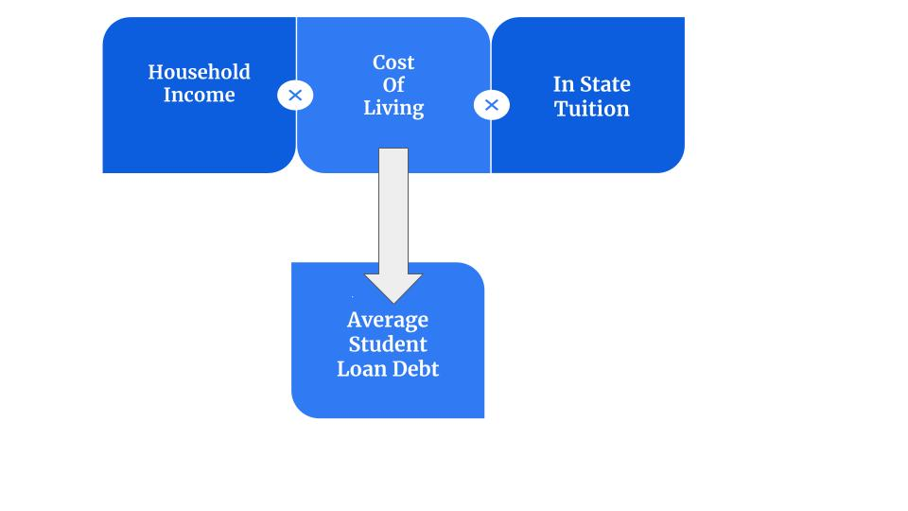

**Analytical Approach**

**Relationships**

Education is a key component on how people can get ahead, but the barriers it takes those in financial need to attend college can cause students to opt out of undergrad and postgraduate school they cannot afford, further widening the gap between their family for generations and the families of those fortunate enough to afford college education. It has been shown through research that a family's financial status can impact the likelihood of a child going to some form of college, and with college being a great tool to gain financial stability, depriving students a chance at an education because money is a factor is not fair. Because finances are an issue when it comes to college decisions, this puts a price value on why that may be the case and how much funding education needs at a higher level.

**Informed Estimate of Findings**

Because college is not cheap, many savings that can start college funds for their children. This model is based on the criteria that a family saves a portion of the yearly salary toward the education of their child if they can afford to after their cost of living. By saving whatever is left over per year, families can spit that toward college debt and avoid student loan debt.This is where families that can afford it will have college paid for outright while their child can keep the rest as start up capital, on the other hand the family who cannot afford to save as much will have a child who will incur debt to get their education, which will inturn start them at a negative, versus a positive of their more affluent counterpart. In the case where states made less their than cost of living, the expected family contribution was given.

This will then cause disparities in how long each individual will take to reach a certain wealth percentile, which can be an indicator of how likely students will attend and how prestigious of a school a child will attend.

**Curation Process**

The data I collected fell into three categories over the span of 2000 to 2016: family contributions, price of living, and future living, which all tried to initially establish a model comparing Black and white households throughout the process of saving and sending children off to college. To get information on family contributions, I researched the average income levels of each state. This would allow me to see the income levels of each state, that would initially give the base average of how much each state made to contribute to their overall savings. I also researched the average cost of living for a household in the US. When taking the two numbers into account you can see the average amount of money each state has leftover on average. When calculating the “expected family contribution” it allowed me to find a set standard of how much a family should contribute to their annual income toward college education. I found that most states on average live in debt and for this study meant most households would have to apply for loans. As I later see how race impacts income levels of each state, I hope to see a correlation in college choice and graduation rates reflecting that of the income levels of each race. I found that the quintile that a family is in financially impacts the rate in which the child from that home would attend college and if they did what type of college they would attend. I hope to show expected student loan debt of each state as a factor in why this may be the case in why different races attend different colleges at different rates despite states offering financial aid.

**Correlation Scores**

Household Income: r = .7138

Cost of Living: r = .4904

In State Tuition Cost: r = .5976

**Significance**

Household Income: p = <.0001

Statistically significant (p <.05)

Cost of Living: p = .0003

Statistically significant (p <.05)

In State Tuition Cost: p = <.0001

Statistically significant (p <.05)

**Correlation Directions**

Household Income: Moderate Positive Correlation

Cost of Living: Slight Moderate Positive Correlation

In State Tuition Cost:Moderate Positive Correlation

**Interpretation & Analysis**

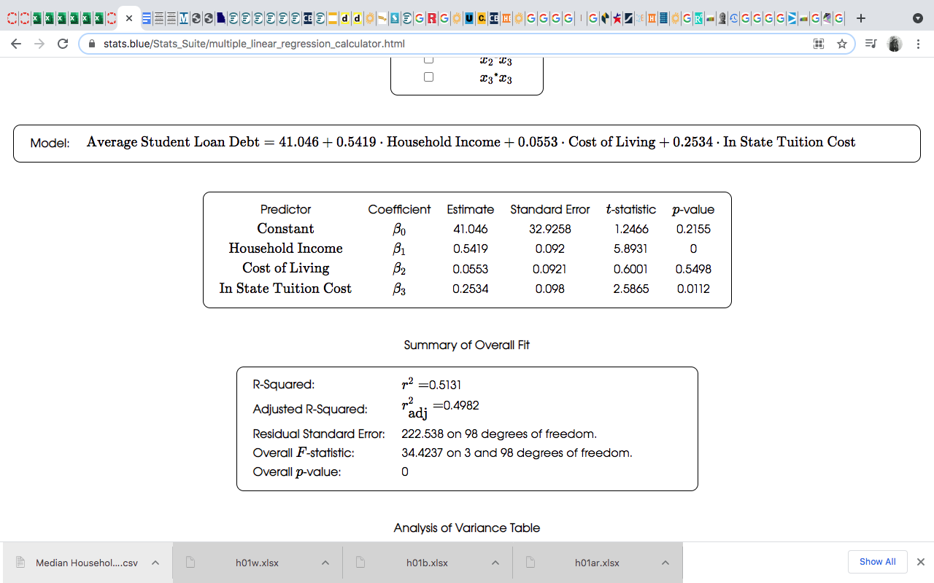***Household Income and Student Loan Debt****:*

The r score for *Household Income* and *Student Loan Debt* was .7138, showing a strong positive correlation between household income and average student loan debt. In the context of the study this shows a correlation between household income and student loan debt throughout each, I see the more a household makes in the state, the more people in that state go to college or can afford more expensive colleges.

The p value for *Household Income* and *Student Loan Debt* was < .0001. This means the null hypothesis was correct, and the probability of the correlation being by coincidence is low. This means the data is statistically significant.

***Cost of Living and Student Loan Debt****:*

The r score for *Cost of Living* and *Student Loan Debt* was .4904. It showed a somewhat positive correlation, but the correlation overall was weak because as x approaches 0, the correlation between cost of living and student loan debt weakened. In the context of the study, I believe student loan debt plays a factor in the cost of living in a state. This is not surprising to me because cost of living was added as a measure to see the income vs outcome level of living in each state. So as the cost of living rises, student loan debt may rise as well, but financial aid does play a factor in how many students afford college. That may be why as x approaches 0 the correlation weakens.

The p value for *Cost of Living* and *Student Loan Debt* was .0003. This means the null hypothesis was correct, and the probability of the correlation being by coincidence is low. This means the data was also statistically significant.

***In State Tuition and Student Loan Debt****:*

The r score for *In State Tuition* and *Student Loan Debt* was .5976, showing a positive correlation. This was expected because in state tuition and student loans are related. As in state tuition rises, student loan debt rises showing the cost of education and student loans you acquire can be tied to where you live. Although these are average in state tuition costs, education changes as you pay more so school being less affordable stunts the education of those who simply cannot afford to continue higher levels of school.

The p value for *In State Tuition* and *Student Loan Debt* was < .0001. This means the null hypothesis was correct, and the probability of the correlation being by coincidence is low. This means the data was also statistically significant.

With the p values of all the coefficients being statistically significant, their values can be trusted more.

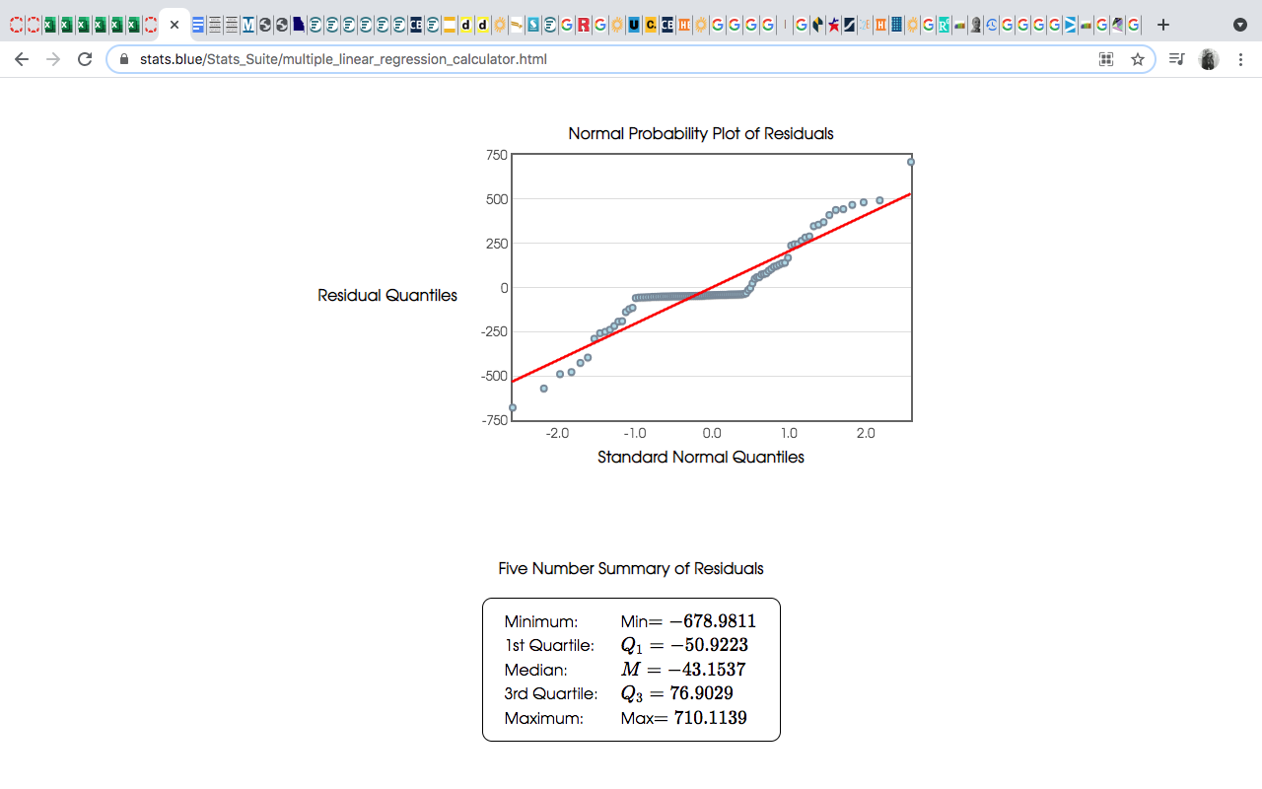

**Multiple Linear Regression**

*Percentage of Variance Explained by the Model = 51.31%*

**Significance Coefficients and Variables**

*Significance*:

* Household Income: p = <.0001
  + Statistically significant (p <.05)
* Cost of Living: p = .0003
  + Statistically significant (p <.05)
* In State Tuition Cost: p = <.0001
  + Statistically significant (p <.05)

**Unstandardized Coefficients**:

*Household Income*: .5419 *positive*

For every 1 unit change in *Household Income Average Student*, *Loan Debt* rises by .5419

*Cost of Living*: by .0553 *positive*

For every 1 unit change in *Cost of Living*, *Average Student Loan Debt* rises .0553

*In State Tuition Cost*: .2534 *positive*

For every 1 unit change in *In State Tuition Cost*, *Average Student Loan Debt* rises by .2543

**Model:**

*Average Student Loan Debt* =

41.046 + (0.5419 * *Household Income*) + (0.0553 * *Cost of Living*) + (0.2534 * *In State Tuition Cost*)

**Interpretation & Policy Making**

It is not a secret that college is expensive. This study tries to show how household income, cost of living, and in state tuition are all related. By doing a state by state unit analysis you can see this as a positive correlation between all variables in each state, making this a country wide problem. My use for this study was to find a ground basis as comparison for averages at a state level to then be used to see how each state compares to the next. My next step would be to see how distribution of wealth between all racial groups is divided on a state by state basis. This will fully show how the fear of student loan debt and the three independent variables this study tried to correlate. In general, this study can show which states are in need of more school funding and financial aid. If all the independent variables of this study rise, so will student loan debt, and these states are at highest risk of disproportionately disadvantaged hopeful college students who cannot go to college because it is simply too expensive.

The findings in this study did not surprise me. The most surprising correlation to me was cost of living and student loan debt. It is easy to imply as families live in states that earn more, they will in turn be able to put more money toward college, but average cost of living per state impacts by average how much debt a family can acquire per year. If average household income and average cost of living create a negative in a household or you can compare a race’s earnings and spending habits to their state’s averages you can see how they compare to that state’s norm. Although this formula and study are not that deeply intricate, this base level per state can be used as a benchmark for financial aid or student loan forgiveness if your family does not make that much. Being a college student a common problem among my peers when it comes to financial aid is their families making too much to qualify, but not enough to afford to pay for college out of pocket. Once cost of living in a state is allotted for when looking at a family’s finances you can see how much on average they can have left over to contribute to college rather than looking at just their earnings.

Hopefully, this study can show policy makers how each state’s student loan debt is contributed to that state’s household income, cost of living, and in state tuition. When looking at these variables under a racial microscope you can see how minority groups are impacted by these variables and how much they are disadvantaged financially when it comes to their peers. Money dictates who has access to the world’s best education, when a thirst for knowledge should be the only criteria to fill those seats. When money has the power to deter people from choosing education, hopefully this study can show policy makes how much funding states need to cover tuition costs when the average American family cannot afford the average in state tuition at their school and have to opt for crippling student loan debt.

**Thoughts & Conclusion**

The limitations of this project were choosing variables that are both independent and dependent that would have some type of impact on each other. I did not want too many variables that were closely related. Timing played a factor in the data curation process as well. For the sake of this study it would have been better evidence if I had the average total income by race on my excel sheet to compare how each race does compared to their state average and how that impacts graduation rate. In my own independent research leading up to my study, I saw how household income level impacts the college and degree choice a person is likely to make based on the quintile of their family. There are also studies that show the graduation rates of each state by gender and race. Paired with my study you can see 1. The variables discussed in my study, versus the household income of each state versus the graduation rates of each state would make for a better overall quality of study for the point I wanted to meet with this research, but time and skill level was a factor. I felt like dealing with too many variables at one time would further overwhelm my research and would not allow me to move forward past the research stage. This is why I chose the variable I chose for the study and suffered through the limitations because the research done prior in the other related fields were so thorough.

My research does have heavy ethical implications. Because my research is heavily rooted in race, I can have biases toward the community I am a part of and the state I live in. Also a study based in race may be controversial when it comes to college funding. No race dictates who needs funding so if you lead the study with this in mind and make legislation with this ideal as your dominant factor you may inversely impact those who come from families who fall short financially. The purpose of this study was to show how household income, in state tuition, and cost of living impact a state’s student loan debt. When you add race as a factor you can see how groups in each state compare to each other. People cannot afford college at this rate and as people prioritize not having crippling debt over college education, the country as a whole will suffer. The more educated a country the better will be, and this is not a race issue, but an issue of college not being affordable at a state level for average Americans.

References

Chevalier, A., Harmon, C., Sullivan, V., & Walker, I. (2013, December 09). The impact of parental income and education on the schooling of their children. Retrieved April 16, 2021, from https://izajole.springeropen.com/articles/10.1186/2193-8997-2-8

Cost of living index by State 2021. (n.d.). Retrieved April 16, 2021, from https://worldpopulationreview.com/state-rankings/cost-of-living-index-by-state

Dedman, B. (2018, July 09). The income gaps in higher education enrollment and completion. Retrieved April 16, 2021, from https://www.aacu.org/aacu-news/newsletter/2018/june/facts-figures

Department, P., & 20, J. (2021, January 20). Household income of black FAMILIES u.s. 2019. Retrieved April 16, 2021, from https://www.statista.com/statistics/203295/median-income-of-black-households-in-the-us/

Department, P., & 20, J. (2021, January 20). Household income of white FAMILIES u.s. 2019. Retrieved April 16, 2021, from https://www.statista.com/statistics/203277/median-income-of-white-households-in-the-us/

Department, P., & 20, J. (2021, January 20). Median household income by Education 2019. Retrieved April 16, 2021, from https://www.statista.com/statistics/233301/median-household-income-in-the-united-states-by-education/

Feds release broader data on socioeconomic status and college enrollment and completion. (n.d.). Retrieved April 16, 2021, from https://www.insidehighered.com/news/2019/05/23/feds-release-broader-data-socioeconomic-status-and-college-enrollment-and-completion

Johnson, D. S., Rogers, J. M., & Tan, L. (n.d.). A century of family budgets in the United States. Retrieved from https://www.bls.gov/opub/mlr/2001/05/art3full.pdf

Kagan, J. (2020, August 28). How much income puts you in the top 1%, 5%, 10%? Retrieved April 16, 2021, from https://www.investopedia.com/personal-finance/how-much-income-puts-you-top-1-5-10/

McCuen@aacu.org. (2017, August 15). Higher education attainment by family income: Current data show persistent gaps. Retrieved April 16, 2021, from https://www.aacu.org/aacu-news/newsletter/higher-education-attainment-family-income-current-data-show-persistent-gaps

N. (n.d.). Post-Bachelor’s Employment Outcomes by Sex and Race/Ethnicity. Retrieved from https://nces.ed.gov/programs/coe/pdf/coe_tbb.pdf

N. (n.d.). The NCES fast Facts tool provides quick answers to many education QUESTIONS (National Center for EDUCATION STATISTICS). Retrieved April 16, 2021, from https://nces.ed.gov/fastfacts/display.asp?id=72

N. (n.d.). The NCES fast Facts tool provides quick answers to many education QUESTIONS (National Center for EDUCATION STATISTICS). Retrieved April 16, 2021, from https://nces.ed.gov/fastfacts/display.asp?id=76

The NCES fast Facts tool provides quick answers to many education QUESTIONS (National Center for EDUCATION STATISTICS). (n.d.). Retrieved April 16, 2021, from https://nces.ed.gov/fastfacts/display.asp?id=31

New census data show strong 2016 earnings growth across-the-board, with black and Hispanic WORKERS seeing the fastest growth for second consecutive year. (n.d.). Retrieved April 16, 2021, from https://www.epi.org/blog/new-census-data-show-strong-2016-earnings-growth-across-the-board-with-black-and-hispanic-workers-seeing-the-fastest-growth-for-second-consecutive-year/#:~:text=Real%20incomes%20increased%205.7%20percent,)%20among%20non%2DHispanic%20whites.

Nichols, A. H., & Schak, J. O. (n.d.). Degree Attainment for Black Adults: National and State Trends. Retrieved from https://edtrust.org/wp-content/uploads/2014/09/Black-Degree-Attainment_FINAL.pdf

Salary by STATE: Where Can you really earn the most? (n.d.). Retrieved April 16, 2021, from https://www.rasmussen.edu/student-experience/college-life/salary-by-state/

Take online Courses. earn college Credit. research schools, DEGREES & careers. (n.d.). Retrieved April 16, 2021, from https://study.com/articles/Average_Salary_With_A_Bachelors_Degree.html

This text provides general information. Statista assumes no liability for the information given being complete or correct. Due to varying update cycles, S. (n.d.). Topic: Cost of living in the United States. Retrieved April 16, 2021, from https://www.statista.com/topics/768/cost-of-living/

U. (n.d.). Learn more, earn more: Education leads to higher wages, lower unemployment : Career outlook. Retrieved April 16, 2021, from https://www.bls.gov/careeroutlook/2020/data-on-display/education-pays.htm

U. (n.d.). Measuring the value of education : Career outlook. Retrieved April 16, 2021, from https://www.bls.gov/careeroutlook/2018/data-on-display/education-pays.htm

USA, D. (2020, August 10). DebtQuest USA. Retrieved April 16, 2021, from https://debtquest.com/average-household-budgets/#average_household_budgets